# “Diveplan.vbp” project files

=================

## frmgasprofile2.frm

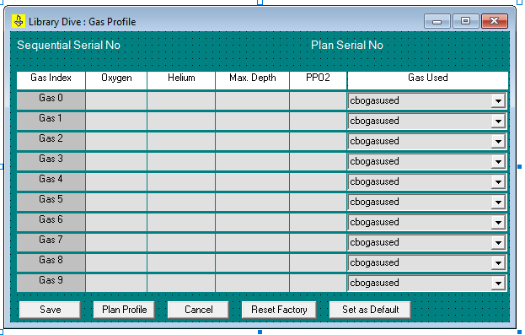

## frmGetStarted.frm

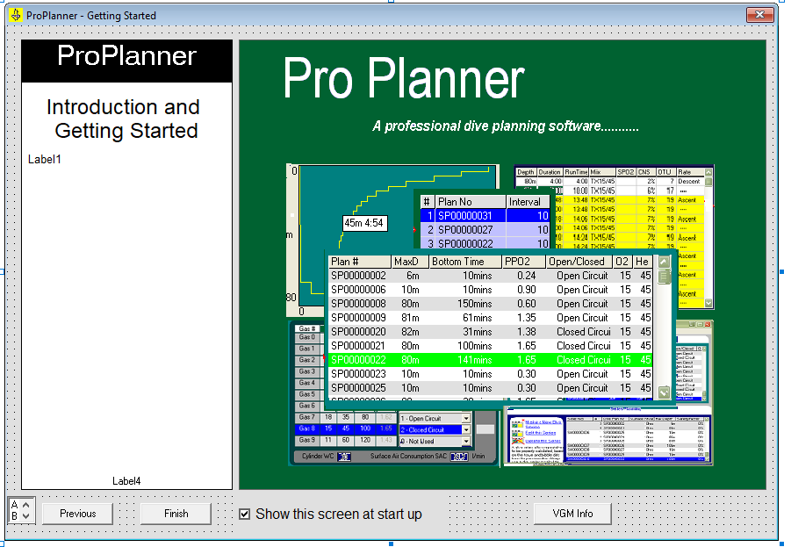

## Intro2.frm

Walkthrough how to operate the planning software.

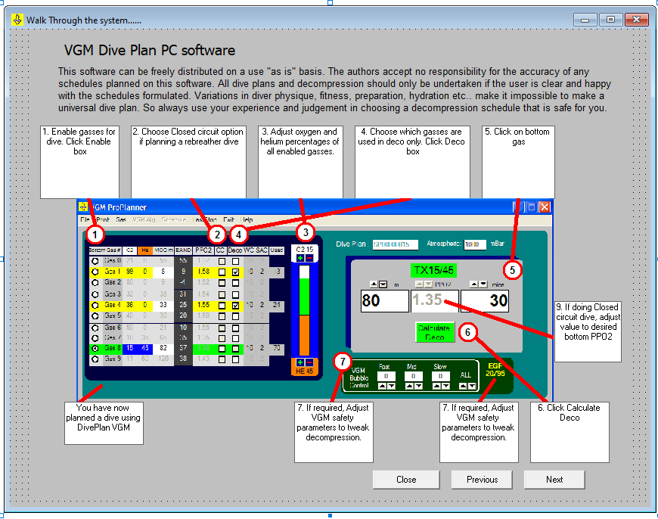

## frmSplash.frm

Splash screen to show product name and version. Plus option to recover database from a file.

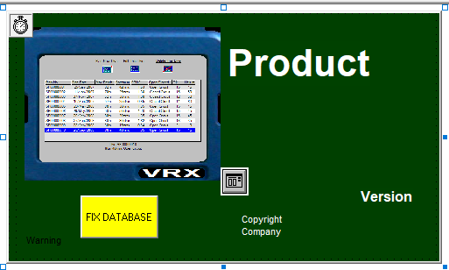

## frmTip.frm

Tip of the day box. Display at startup.

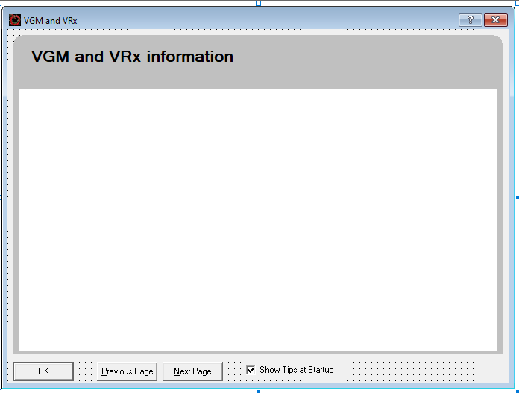

## Planprofile2.frm

The single dive planning window. Select gas for descent/bottom time. Optionally select gases to use during decompression on the ascent. Select if the gas is breathed open circuit or closed circuit. Choose the VGM bubble control (?) for fast/middle/slow. Show the equivalent gradient factor of the setup.

Contains the decompression algorithm implementation!

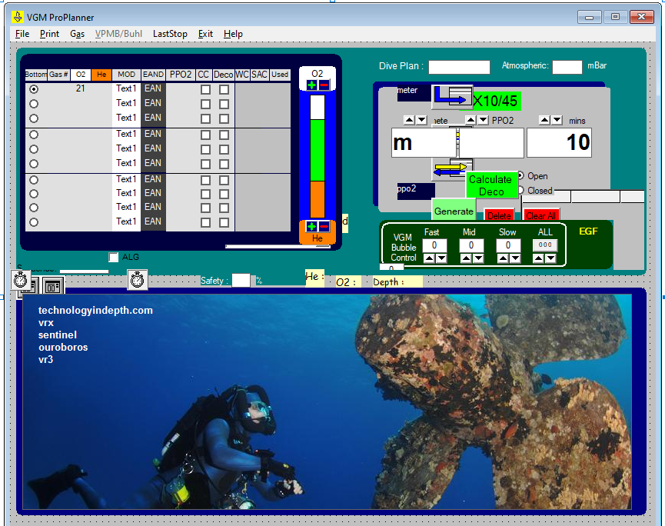

## seqdpmain.frm

Like a library of dives. They are considered separately unless they are added to a Dive Series. Various menu options like save/load.

